VISVESVARAYA TECHNOLOGICAL UNIVERSITY



JNANA SANGAMA, BELAGAVI - 590018, KARNATAKA, INDIA



Internship Report on

# “Analysis of Software Defined Network Firewall (SDF)”

Submitted in partial fulfilment for the award of degree of

### Master of Technology In

Computer Network Engineering

Submitted by

Syam. S (1AT17SCN04)

Internship carried out

### at

LMT (Logic Mind Technology) Software Solutions Pvt Ltd

#39/11, Service Road, Remco Layout, Vijaya Nagar, Bangalore ,Opp. BMTC Bus Depot, Bengaluru, Karnataka 560040

### Internal Guide External Guide

Abhilash Sasi Kumar

Assistant professor Software Engineer

Atria Institute of Technology WEBER TECHNOLOGIES

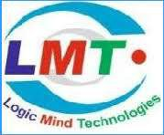

ATRIA INSTITUTE OF TECHNOLOGY DEPARTMENT OF INFORMATION SCIENCE AND ENGINEERING

ASKB Campus, Anand nagar, Bengaluru-560 024

2018-2019

1



### Atria Institute of Technology

Department of Information Science and Engineering



Certificate

### Certified that the Internship Report titled “Analysis of Software Defined Network Firewall (SDF)”” has been carried out by Mrs.Syam.S(1AT17SCN04) bonafide students of Atria Institute of Technology, in partial fulfilment for the award for III Semester of M.Tech in Computer Network Engineering under Visvesvaraya Technological University, Belgaum, during the year 2018-2019. It is certified that all corrections/suggestions indicated for internal assessment have been incorporated in the report. The internship report has been approved as it satisfies the

academic requirements in the respect of internship work prescribed for the said degree.

|  |  |  |
| --- | --- | --- |
| Signature of the guide  Internal Guide | Signature of the guide  External Guide | Signature of the HOD  Dr.Shanthi Mahesh |
| Abhilash | Mr. Sasi Kumar, | Associate Prof & HOD, |
| Assistant professor  Dept. of ISE AIT, Bengaluru. | Software Engineer,  Logic Mind Technologies Limited, Bengaluru. | Dept. of ISE, AIT, Bengaluru |

2

# ACKNOWLEDGEMENT



I am grateful to my institution, Atria Institute of Technology, for having provided me with the facilities to successfully complete this Internship report on Analysis of Software Defined Network Firewall (SDF)”.

I thank Shri A S Chinnaswamy Raju, Chairman, Dr.K.S.Rajanandam , principal and Dr.Shanthi Mahesh, HOD, ISE for providing us all the necessary facilities for successful completion of our internship report.

Deadlines play a very important role in successful completion of the academic internship work on time, efficiently and effectively. I take this opportunity to express our deep sense of gratitude to our guide Abhilash, Assistant professor, Department of ISE for her valuable guidance and help throughout the course of the academic internship report. They have always been patient with me and helped immensely in completing the task on hand. I also thank her for her immense support, guidance, specifications & ideas without which internship report would have been completed without full merit.

I would like to say thanks to Professor Shanthi Mahesh without whom this report would have been a distant reality. Last but not least I would say thank to the Department of Information Science and Engineering, teaching and non-teaching staffs for their constant encouragement, support, patience and endurance shown during the preparation of this report.

Finally, I thank my parents and friends for their motivation, moral and material support

Place: Bengaluru Signature of the student

Date:12-09-2018 Name: Syam S

USN: 1AT17SCN04

III Semester M-Tech in CNE

3



# DECLARATION

I, Syam. S (1AT17SCN04), Student of third semester Master of Technology, Atria Institute of Technology hereby declare that the internship entitled “Analysis of Software Defined Network Firewall (SDF)” has been carried out by me at LMT (Logic Mind Technology) Software Solutions Pvt Ltd, Bengaluru and submitted in partial fulfilment of the course requirements for the award of the degree of Master of Technology in Compute Network Engineering of Visvesvaraya Technological University, Belgaum, during the academic year 2018-2019.

I also declare that, to the best of my knowledge and belief, the work reported is the orginal work done by me in respective organization.

### Syam .S 1AT17SCN04

4

### ABSTRACT



Software denned networking empowers network operators with more edibility to program their networks. With SDN, network management moves from codifying functionality in terms of low-level device conjurations to building software that facilitates network management and debugging.

By separating the complexity of state distribution from network specification, SDN provides new ways to solve long-standing problems in networking routing, for instance while simultaneously allowing the use of security and dependability techniques, such as access control or multi-path.

However, the security and dependability of the SDN itself is still an open issue. In this position paper we argue for the need to build secure and dependable SDNs by design. As a rest step in this direction we describe several threat vectors that may enable the exploit of SDN vulnerabilities.

We then sketch the design of a secure and dependable SDN control platform as a materialization of the concept here advocated. We hope that this paper will trigger discussions in the SDN community around these issues and serve as a catalyser to join ports from the networking and security & dependability communities in the ultimate goal of building resilient control planes.

5

### INDEX



ACKNOLWEDEMENT ……………………………………………………………… 3

DECLARATION …………………………………………………………………….…... 4

ABSTRACT …………………………………………………………………………… 5

INDEX ………………… ………………………………………………………………… 6 LIST OF FIGURES ……………………………………………………………………... 9 LIST OF TABLES ………………………………… 10

1 ABOUT THE COMPANY ……………………………………………………………….. 11

1.1 Company Profile …………………………………………………………….. 11

* 1. VISION 11
     1. Our Values… 11
     2. Our Goals 13
  2. Mission 14
  3. About LMT Software Solutions Pvt Ltd 14
  4. Growth Record 15
     1. Our Customers 15
     2. Partnership 15
     3. Experience certainty 16
  5. Corporate Philosophy 16
     1. Quality Policy 17
     2. Security Policy 17
  6. Organization Structure 18
     1. Current Research and Development 19
     2. New Technology Capability and Positions 19

2 About The Department ………………………………………………………………. 20

* 1. Research and Development Centre …………………………………………... 20 2.1.1 System Software and Programming Tools 21

2.1.2 Traditional IT Organisational Structure Issues 23

* 1. Department Centered Organizations 24

6

2.2.1 Major Service Offerings 25



3 TASKS PERFORMED ……………………………………………………………… 36

3.1 Overview …………………………………………………………………… 37

3.2 Scope and Objective of the Project …………………………………………. 37 4 EXISTING WORK ………………………………………………………………… 37

4.1 Problem Statement ………………………………………………………….. 37

4.2 Objective …………………………………………………………………….. 37

4.3 Keywords ……………………………………………………………………... 38

4.4 Methodology ………………………………………………………………….. 38

4.5 Security & Dependability …………………………………………………….. 38

5 PROPOSED SYSTEM ……………………………………………………………….. 40

6 WHAT IS SDN ………………………………………………………………………. 40

6.1 SDN architecture ……………………………………………………………. .40

6.2 How SDN works ……………………………………………………………... 42

6.3 Benefits of SDN ……………………………………………………………….44

6.4 Challenges with SDN ……………………………………………………….…45

6.5 SDN Tool Images …………………………………………………………….. 46

7 WIRELESS SENSOR NETWORK …………………………………………………... 52

7.1 Block Diagram ……………………………………………………………….. 52

8 ROTA ALGORITHM ………………………………………………………………… 53

9 APPLICATION OF SDN ………………………………………………………… 54

10 PROJECT OUTCOMES ……………………………………………………………… 56

11 USE CASE …………………………………………………………………………… 56

12 CHALLENGE ………………………………………………………………………… 56

13 SOME FREQUENTLY RAISED QUESTIONS ……………………………………… 56

14 CONCLUSION …………………………………………………………………… 57

15 REFERENCES ………………………………………………………………………… 58

7

### LIST OF FIGURES



FIGURES DESCRIPTION PAGENO

|  |  |  |
| --- | --- | --- |
| Fig 1.1 | Organization Structure | 08 |
| Fig 2.1 | System Software and programming tools | 12 |
| Fig 2.2 | IT organization layers | 15 |
| Fig 2.2.1(a) | Snapshot of andrafresh.com | 17 |
| Fig 2.2.1(b) | Alliances with Andrafresh.com symbol | 17 |
| Fig 2.3 | Snapshot of andrafresh.com | 30 |
| Fig 2.4 | Alliances with Andrafresh.com symbol | 30 |
| Fig 6.1 | SDN Layers | 41 |
| Fig 6.1 | SDN Architecture | 42 |
| Fig 6.5 | SDN Tools | 51 |
| Fig 7.1 | Wireless sensor Block diagram | 52 |

8



### LIST OF TABLES

TABLE DESCRIPTION PAGE NO.

Table 2.1 Roles Performed 22

9

* 1. Company Profile



ABOUT COMPANY



With the active participation of its multi-disciplinary Assignment Execution Team, LMT (Logic Mind Technology) Software Solutions Pvt Ltd. has emerged as a leader in the ITES in India and has established itself in the field of software development, data processing, data conversion, digital printing, Digitization, System integration, smart card personalization, IT facility management and other IT enabled services. LMT Software Solutions Pvt Ltd., incorporated in 2011, is a professionally managed, rapidly growing, multifaceted Information technology company. The company is actively involved in developing automation and e-Governance solutions for Transport, Social Security, Citizen Identity, Education, Public Distribution System, Retail Management and a host of other application areas.

LMT Software Solutions Pvt Ltd. is a leading System integrator in India providing complete turnkey solutions on BOO & BOOT basis including facility management services, Smart Cards applications, Document Management System (DMS), Work Flow Management and Manpower Deployment.

LMT Software Solutions Pvt Ltd. has successfully completed many e-governance projects for the various departments of Govt of AP and has won accolades for its superior service delivery, timely execution of projects and the quality of the deliverables. LMT is being trusted by many clients who

10

are looking for reliable and quality services for their business. LMT is currently operating and managing in Bangalore and giving services to e-commerce business services.



LMT Software Solutions Pvt Ltd. adopted project team and dedicated organization structure. In project based organization, the project manager’s directors have a high level of power to oversee and control the project assets. The project manager in this structure has downright power over the project and can secure assets expected to fulfil project targets from inside then again outside the parent organization, subject just to the extension, quality, furthermore, budget constraints are identified in the project.

In the project based structure, staff is particularly relegated to the project and report specifically to the project manager. The project manager is in charge of the execution evaluation and vocation movement of all undertaking colleagues while on the project. This prompts expanded project faithfulness. Complete line power over undertaking endeavours bears the project manager solid undertaking controls and brought together lines of correspondence. This prompts quick response time and enhanced responsiveness. In addition, project work forces are held on a restrictive instead of shared or low maintenance premise. Project teams create an in number feeling of task recognizable proof and possession, with profound faithfulness efforts to the project and a decent comprehension of the way of project's exercises, mission, or objectives.

## Contact Information

Company Name : LMT Software Solutions Pvt Ltd.

Development &

Data Processing Centre : #17/46, 1st Floor, Service Road

Remco Layout, Bangalore-40. General Phone No : 080-41155670

Company Email : [info@lmtsoftware.com](mailto:info@lmtsoftware.com) Website : [www.lmtsoftware.com](http://www.lmtsoftware.com/) Contact Number : 9036159759

11

## VISION



Vision Statement:

#### “To be the pioneer in e-commerce solutions by building and implementing robust and future proof systems which are efficient, transparent and accountable.”

### Our Values:

The core values which lay the foundation for LMT Software Solutions Pvt Ltd. are:

* + - * Honesty & Integrity:

LMT Software Solutions Pvt Ltd. individual and business relationships are governed by the highest standards of honesty and integrity. People at all levels adhere to the code of conduct and the highest standards of business ethics, as they believe in conducting their business with uncompromising integrity.

* + - * Respect & Dignity:

LMT Software Solutions Pvt Ltd. respects its customers, recognize that they have different needs and continuously strive towards satisfying those needs by improving the quality of its solutions and services. It trust and respect its people and recognize their contributions to LMT Software Solutions Pvt Ltd..

* + - * Terms Spirit & Camaraderie:

LMT Software Solutions Pvt Ltd. believes that focus on Team Work is its competitive advantage. Teams act as catalysts for successful achievement of the organizational goals. Individuals are encouraged to interact with all levels of management, freely share their ideas and suggestions and work together as a cohesive unit.

* + - * Openness & Transparency:

LMT Software Solutions Pvt Ltd. has an open and transparent culture. Openness facilitates informed decisions, shared understanding and builds an environment of trust in the organization.

* + - * Empowerment:

LMT Software Solutions Pvt Ltd. employs high caliber

12

people who take responsibility for their actions and exercise good judgment in an environment of mutual trust. LMT Software Solutions Pvt Ltd. seeks to retain its entrepreneurial spirit and minimize bureaucracy.



* Core Values:When we take on your project, we take the stewardship of the project with you in the director’s seat. As stewards of your project, we consider ourselves successful not when we deliver your final product but when the product meets your business objectives.
* Integrity:Honesty in how we deal with our clients, each other and with the world.
* Candour:Be open and upfront in all our conversations. Keep clients updated on the real situation. Deal with situations early; avoid last minute surprises.
* Service:Seek to empower and enable our clients. Consider ourselves successful not when we deliver our client’s final product but when the product is launched and meets success.
* Kindness:Go the extra mile. Speak the truth with grace. Deliver more than is expected or promised.
* Competence:Benchmark with the best in the business. Try new and better things. Never rest on laurels. Move out of comfort zones. Keep suggesting new things. Seek to know more.
* Growth:Success is a journey, not a destination. Seek to multiply/increase what we have - wealth, skills, influence, and our client’s business.

### Our Goals:

Our company objectives as follows:

* + - * To promote a profitable and sustainable business activity that meets the customer’s needs.
      * To increase the company's market share
      * To gain the competitive edge
      * To increase the company's role in relations to social responsibility
      * To provide excellent customer service

13

## Mission



“To enable its customers to achieve total e-commerce through innovative solutions using the cutting edge technologies and to provide world class IT and ITES services at an affordable costs to the customers with fast turn around time and to continually improve the service delivery at the client service centres managed by us.”

Over the next few years our goal is to harness our talents and skills by permeating our company further with process-centered management. In this way, once a customer's project enters our quality oriented process, it will exit as a quality product.

We will also strive to add to our knowledge and enhance our skills by creating a learning environment that includes providing internal technology seminars, attending conferences and seminars, building a knowledge library and encouraging learning in every way. Our in-house Intranet portal makes sure that knowledge is shared within the organization.

With our beliefs, the future can only look promising as we continue to build our team with the best Indian talent and mould them into our quality-oriented culture. We will find our niche in a competitive world by excelling at what we do, following our guiding principles and most importantly, listening to the needs of our customers, to complete within deadline period is also our mission.

## About LMT Software Solutions Pvt Ltd.

LMT Software Solutions Pvt Ltd. Pvt Ltd is one of India most well-known and well-trusted solution provider. Today, LMT Software Solutions Pvt Ltd. stands as a source of reliable and innovative products that enhance the quality of costumer's professional and personal lives.

LMT Software Solutions Pvt Ltd. is rooted in Bangalore and has its branch in Hyderabad and Chennai. LMT Software Solutions Pvt Ltd. is a leading solution provider in all technologies, and has extensive experience in research and development.

Its employees in all the branches are active in the areas of production, software development, Implementation, system integration, and training.

Why LMT Software Solutions Pvt Ltd.?

With a client list spanning nearly in all industries, and colleges, LMT Software Solutions Pvt Ltd. product solutions have benefited customers of many different sizes, from non-profit

14

organizations to companies.



By acquaintance with LMT Software Solutions Pvt Ltd. you’ll have access to current IT research, tools, templates, and step-by-step action plans for completing Key projects.

You’ll also be provided full access to our research archives and knowledge base.

## Growth Record

Since its inceptions and with initial small steps, LMT Software Solutions Pvt Ltd. is now progressing by leaps and bounds. It has grown from a small venture to a medium scale enterprise with a strong 80+ workforce, our rate of more than 100%. The company is executing some of the prestigious projects and has earned a very respectable name in the Indian IT and e-commerce industry.

### Our Customers

LMT Software Solutions Pvt Ltd. have improved the quality of communication and satisfied customers. We have earned their respect by providing excellent products and services.

In addition, we are flexible with services and financial structures for contracts aiming for mutually beneficial relationships with our customers.

Our customers are dynamic and diverse and include Large Corporate Offices, Universities, Educational Institutions, Factories, etc.

### Partnership

Our innovative and highly integrated approach means customers benefit from working with specialists. Our continuous strive to be a technology leader in the industry means that our clients directly benefit from the huge expertise that our people possess.

We strive to be at the forefront of technology that enables us to provide you with highly effective and optimized solutions to all your problems.

Clients like to have a single point-of-contact for their solutions, and expect a complete solution from the vendor, which is not possible unless there are partnerships and alliances within and outside the company.

15

LMT Software Solutions Pvt Ltd. fosters partnerships with companies with whom a value proposition can be offered to clients.



One of the key benefits that you receive by partnering with LMT Software Solutions Pvt Ltd. is increased project completion certainty, project transparency, renewed customer confidence and credibility from our unparalleled track record, mature processes and quality recognition and customer endorsement.

### Experience certainty

True certainty of success comes from working with a partner you trust to provide the insight, support and expertise that will propel your business forward. Experiencing certainty with LMT Software Solutions Pvt Ltd. means you can count on results, partnership and leadership. When you work with us, your long-term success is our motivation. This is why we can offer you the ability to meet every challenge and the agility to capitalize on every opportunity. That’s the power of certainty. And it is our promise to every client.

## 1.6 Corporate Philosophy

### 1.6.1 Quality Policy

“LMT Software Solutions Pvt Ltd. is committed to provide world class Information Technology Enabled Services (ITES) to its customers with high accuracy, unmatched quality and fast turnaround time”.

1.6.2 Security Policy

“LMT Software Solutions Pvt Ltd. understands that the trust of the client in it depends on how well it keeps their personal, business and accounts information secure. LMT follows international standards set under Information Security Management System (ISMS) policy guidelines.”

## Human Resource

LMT Software Solutions Pvt Ltd. employs more than 80 professionals with various skill set and professional competence. Have different project execution teams for different application areas in Information Technology Industry. The Human Resources available with LMT, their qualification and technical skills are depicted below.

16



Human capital is our most important asset. A qualified and highly specialized team with multi- disciplinary approach forms the technical core at LMT Software Solutions Pvt Ltd. This repository of talented and committed software developers has a proven track record to ensure success in IT solution implementation. With skills ranging from business process re-engineering to application development, LMT Software Solutions Pvt Ltd.'s technical team seeks to constantly enhance and expand its technical knowledge. Capturing knowledge through procedures and processes is the premise on which the entire organization works. LMT Software Solutions Pvt Ltd.'s resource base consists of IIT engineers (three including the Directors), management graduates, masters in computer applications and domain experts from various fields.

## Organization Structure

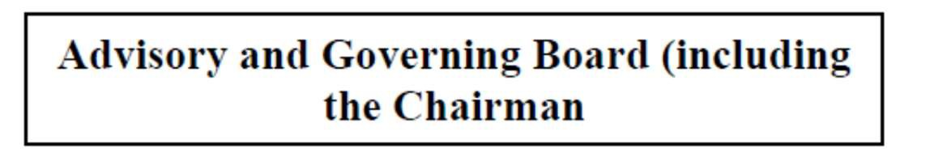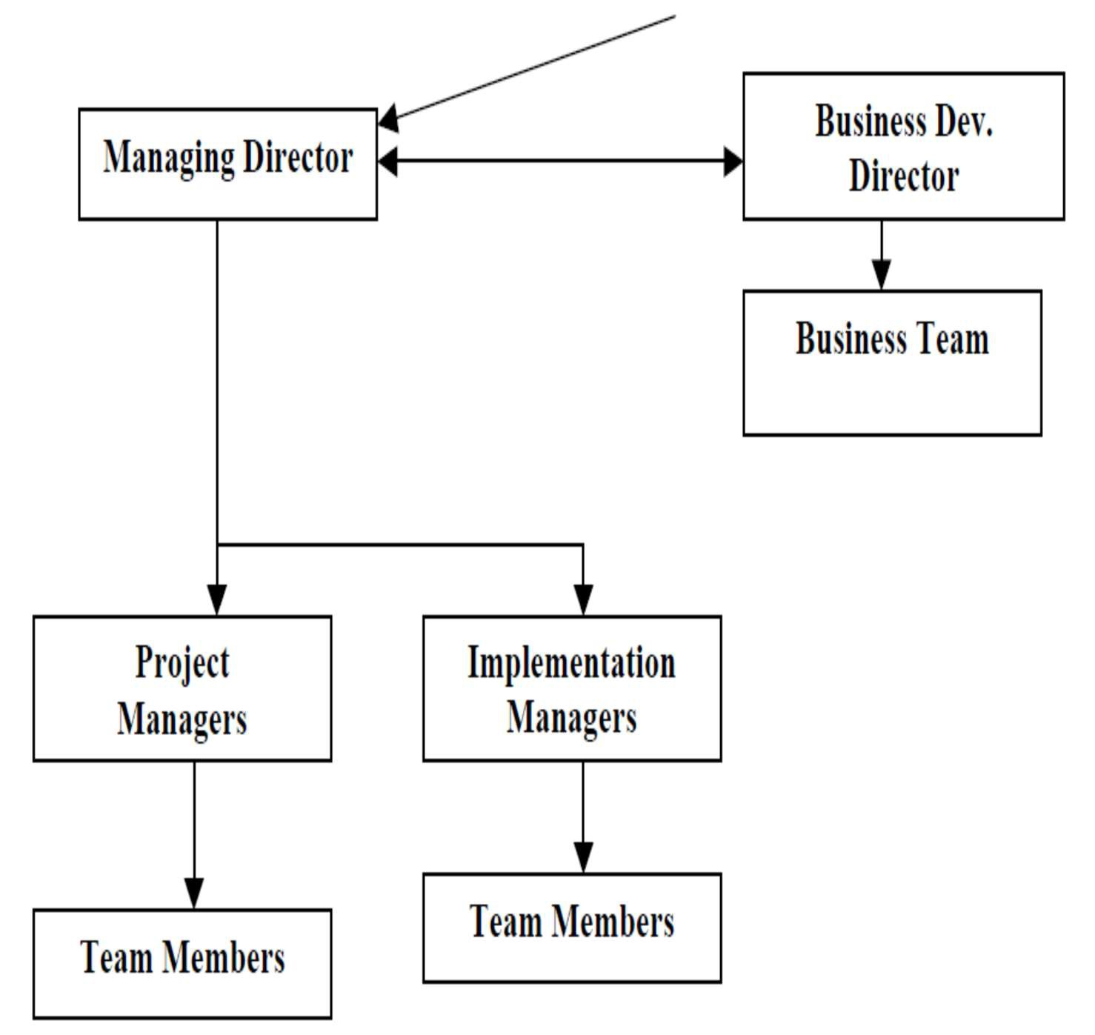

#### Fig 1.8.1 Organization Structure

17

1.8.1 Current Research and Development



* The current R & D efforts are primarily aimed at the following segments in the healthcare industry:
* Developing a system for integrating medical schools with major hospitals for knowledge gathering, sharing and learning
* Developing a Clinical Decision Support System to aid doctors in difficult to diagnose cases using Artificial Intelligence and Probabilistic Techniques.

### 1.8.2 New Technology Capability and Positions

The organization has a process in place, which addresses the issue of incorporating emerging technologies into the product design. The process is as follows:

* Core committee on new development evaluates and identifies new technology for the purpose of integration.
* The research and development department identifies the resource and people and 1formulates the process for working while setting key performance indicator.
* A thorough study of the new technology along the tools is made and documented.
* Estimates are made as to the impact of the new technology on the products developed by the company.
* Effort estimates are made for introducing the new technologies
* Client feedback is received about the efforts needed and the advantages of the new technology.
* The core committee takes a knowledgeable decision as to the advantages and efforts required and approve the introduction of the technology
* The affected personnel are trained in the new technologies
* The new technology is introduced and the product is enhanced
* The clients are informed about the enhancement and introduction of related documents are prepared for the changeover
* The clients are guided in implementing the new technologies

Being a technology driven company we are always exploring ways of enhancing our product capabilities and aim at providing the latest state-of-the-art products to our customers. We have incorporated the PDAs and the smart card already in the system. We are currently evaluating blue tooth capability and the Tablet PC relevance to the field.

18

# ABOUT THE DEPARTMENT



## Research and Development Centre

LMT Software Solutions Pvt Ltd. have the ability to architect, develop and maintain any complex software applications. LMT Software Solutions Pvt Ltd. development team and research team is committed to continuing research and development in the rapidly evolving fields of software development and IT, so that informed decisions can be undertaken at the appropriate time regarding future technology choices and adoption and to help drive the continuing evolution of our software architecture.

Over the course of several years, LMT has used the benefit of its knowledge and experience of developing enterprise wide, web based applications coupled with its continuing research and development activity to develop its own in-house web based software architecture and supporting framework on which all of its current and future web based solutions are based. Conforming to the latest industry standards and best practice, LMT’s software architecture has proven to be a reliable, robust, and scalable foundation on which to build its software products. A qualified and highly specialized team with multi-disciplinary approach forms the technical core at LMT Software Solutions Pvt Ltd.. This repository of talented and committed software developers has a proven track record to ensure success in IT solution implementation. With skills ranging from business process re- engineering to application development, LMT Software Solutions Pvt Ltd. technical team seeks to constantly enhance and expand its technical knowledge. Capturing knowledge through procedures and processes is the premise on which the entire organization works. LMT Software Solutions Pvt Ltd. resource base consists of IIT engineers (three including the Directors), management graduates, masters in computer applications and domain experts from various fields

LMT Software Solutions Pvt Ltd. has a state of the art Software Development Centre located at Delhi which also hosts a Data Centre with 100 MB bandwidth for the data transfer. The development centre and data centre runs in fully secure mode

#### LMT Software Solutions is very prompt providing projects within deadline of project, which it improves the reliable and robustness.



* + 1. System Software and Programming Tools

The software team at LMT Software Solutions Pvt Ltd. has extensively worked on various flavours of Unix and Windows based environment. Few of the Unix operating systems, which have been used by the organisation, are Sun Solaris, Tru64 UNIX & Linux.

The team at LMT has developed large scale and complex applications on Oracle, SQL Server and DB2. There is also substantial working expertise on MySql and MSAccess.

LMT Software Solutions stay relevant to their enterprise customers by helping them with transformational technology solutions utilizing SMAC structure and help in their growth journey and tailored offerings under various technology domains has been providing best quality, timely & cost effective solutions to its clients & has developed a long term strategic partnership with them all across the world.

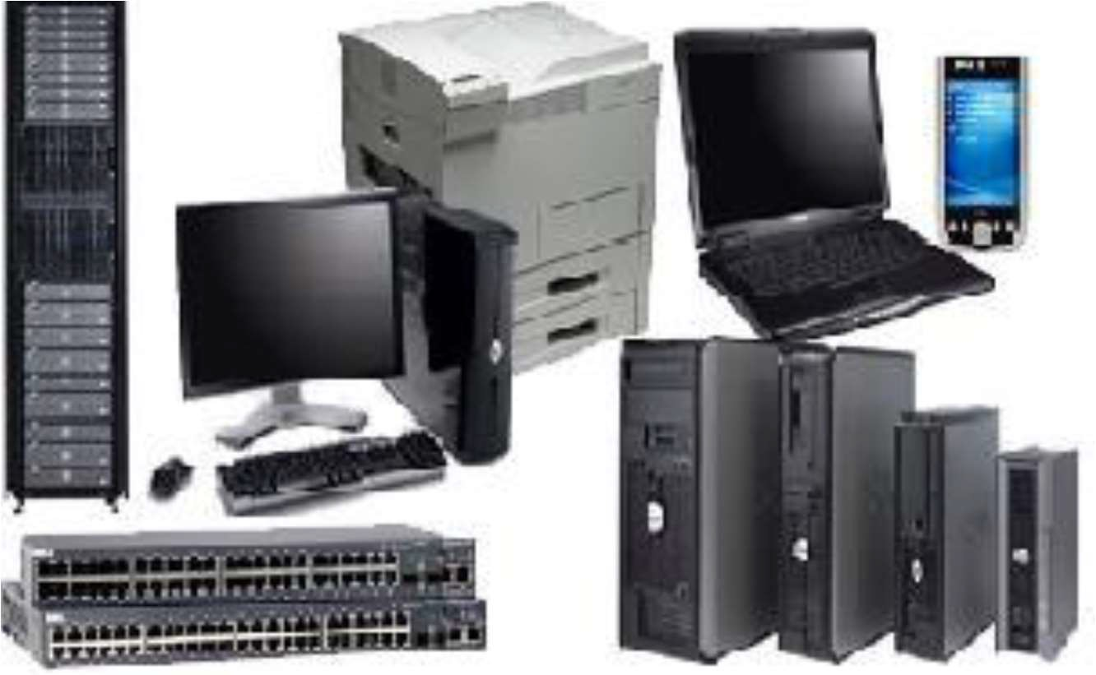

#### Fig 2.1 System Software and programming tools

The web server experience extends to the following:

* Apache on Unix and NT Servers
* IIS on NT Platforms
* J2EE Compliant web servers (JSP version 1.10 & Java Servlet version 2.2)
* Netscape Server



* Oracle Web Server

Operating Systems : OS/400, UNIX, Windows 8, Windows 3.11/8.1/10 Database Environment: DB2, Oracle, SQL Server, MS Access, MySQL, CICS

Languages : Java, EJB, XML, RMI, WAP, C/C++, CL/400, RPG, ActiveX, ASP and COBRA

Web Enabled Systems: MS-IIS, Visual Interdev, Websphere, Weblogic

Front End Tools: Visual Basic, Visual C++, Power Builder, VisualAge, Jbuilder, Developer 2000

Web Designing Tool : FrontPage 2000, Flash Data and Object Modelling : Rational Rose

Our Team members have extensive knowledge in Oracle Products ranging from Oracle 7.3 to 10i, Developer 6i, Oracle 10iAS and other oracle products.

Goal management is about more than just the annual assigning of goals and reviewing of employee performance. It's about getting every employee to use and develop their talents, skills and experience to help the organization meet its overarching goals. Goal setting is one of the most critical steps in effective performance management. Too often, managers and employees set goals that are not SMART or in line with corporate strategies, resulting in lost productivity and disengaged workers. Goal management is more than just a once-a-year exercise – it is an opportunity to align the focus of the entire company, clarify performance expectations, and guide employees to success.

Employee Perform makes it easy to align employee goals with business objectives and effectively guide employee performance and development year-round.Employee Perform flexible performance reviews helps link employee goals to the departmental goals, and to organizational goals

- ensuring every employee is devoting his or her time and attention to critical and important activities.

|  |  |  |  |  |  |
| --- | --- | --- | --- | --- | --- |
| SET | ALIGN | | | MONITOR | ASSESS |
| Employee | Easily | cascade | the | Log in year-round to | Measure goals using |



|  |  |  |  |
| --- | --- | --- | --- |
| performance makes it easy for managers and employees to set SMART goals at the beginning of review cycle. | company objectives to individuals or teams and link personal goals to organizational success | update and comment on goals and track progress throughout the entire review cycle. | any rating scale that you choose. Comments & 360° feedback help ensure ratings are clear and accurate. |

* + 1. Traditional IT Organizational Structure issues

Traditional IT organizations are typically structured to support vertical business units and applications. The roles, responsibilities, skills and budgets are focused on several discrete projects that address specifically business activities .In the traditional IT organization, projects are scoped and implementedwithout fully recognizing the core business processes that span business units.

Without an enterprise view, organizations lose the opportunity to implement the most effective solutions. In addition, typically the business requests enhancements to existing applications as a way to address immediate business needs quickly. This, along with a lack of shared vision between IT and business areas, results in enhancements to applications without fully considering the underlying business processes.

Marketing department advances the business and drives offers of the items and administrations. It gives the vital exploration to recognize and target clients and different audiences.The marketing department consists of Marketing and Sales departments. The presales department further contains Healthcare, Education, Retail and Networking departments. Thus opportunities to radically improve business processes are overlooked.



Fig 2.2 IT organization layers

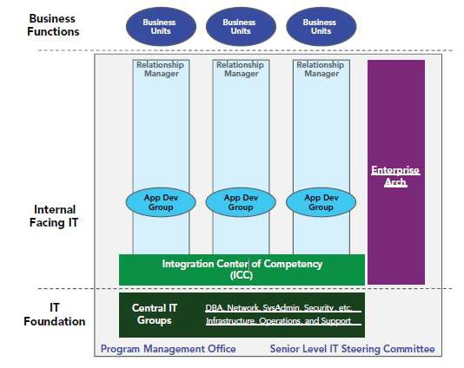

## Department Centered Organizations

Department centered development organizations start to become practical as a group grows above 25 developers or 5 projects. At these staffing levels, there are sufficient people to form multiple departments centered on particular software skills or life cycle areas. For instance, a 40-person group might have departments for:

* System and database administrators
* User interface programmers
* Application programmers
* Configuration management, test, and quality assurance

A common mistake in department-centered organizations is to break software architects into a separate department or group. We have found this can lead to elitism and be very counterproductive. First, it starts to separate the architects from the developers who are doing the actual implementation. Architects thus become more quickly out-of-touch with the latest development methodologies actually being used. Also, while every developer does not want to be an architect, every developer likes to have some say in the design. If developers are too separated from architects, they may have a built-in incentive to prove the architect’s design was wrong by not working there hardest to implement it. When this happens the architect will most likely blame the problem on developer incompetence than on any architectural flaws. The whole iterative development process becomes harder to implement smoothly.



* + 1. MAJOR SERVICE OFFERINGS

LMT Software Solutions Pvt Ltd. has ready to implement solutions for e-Commerce which can be customized and implemented at a short notice. These solutions are developed after conducting detailed System Requirement Study (SRS) of the respective business and have stabilized by the live implementation and are running successfully with state wide implementation.

The marketing department consists of Digital Marketing and Sales departments. The presales department further contains Healthcare, Education, Retail and Networking departments. The digital marketing departments are classified as Public relations, Analyst and Online supermarket for the groceries.

* + - * ONLINE SUPERMARKET FOR THE GROCERIES: ANDHRAFRESH.COM

ANDHRAFRESH.COM is an Indian online grocery provider listing over 2000+products from more than 500 brands. It was started in Anathapur and subsequently expanded its operations to Kurnool, Tirupati and expanding further in Bangalore, Chennai, Hyderabad, Mysore, Pune.

ANDHRAFRESH.COM product categories include Fresh Fruits and Vegetables, Grocery and Staples, Bread, Dairy, Eggs, Beverages, Branded foods, Household Items, Personal Care, Health care, Meat, Home & Kitchen Products, Electronics & Appliances, Cosmetics, imported products and gourmet products. Many more categories are going to be expanded.

#### Andhrafresh.com also provides all fresh beverages, foods and home appliances The below showed snapshot of andrafresh.com

24

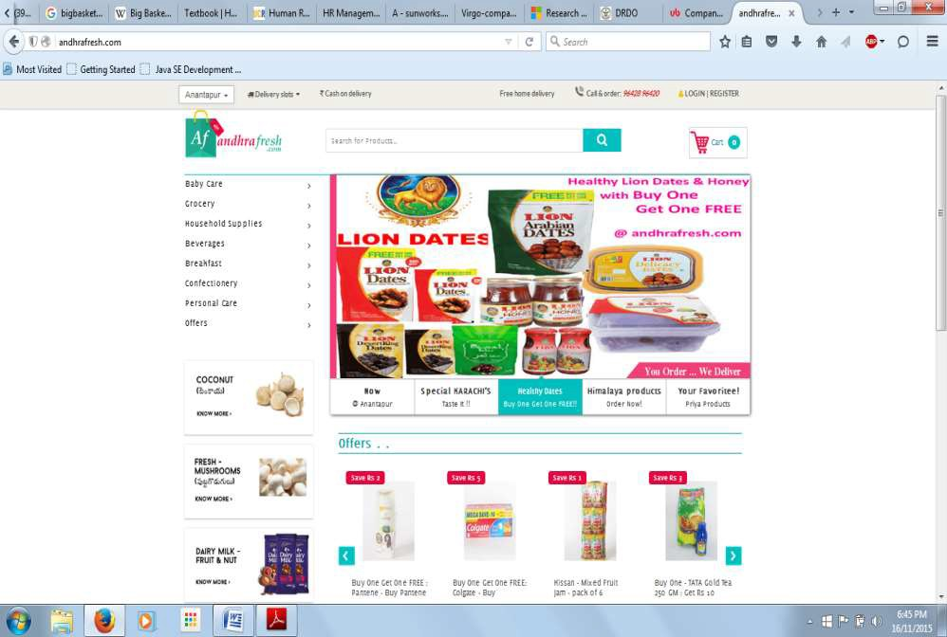

#### Fig 2.3 snapshot of andrafresh.com

* + - * KEY ALLIANCES/PARTENERSHIPS:



#### Fig 2.4 Alliances with Andrafresh.com symbol

Today a client shop on the web at stands via telephone and cells quickly, its big challenge in coordinating to the online stores, to give best shopping is very big challenge.

25



LMT Software Solutions uses advance tools to connect people to fulfill their requirements, areas of specialty of LMT Software Solutions are.

* + - * Responding to customer requirements.
      * Cooperating with customers.
      * Giving presentation to the customers.
      * Business development support.
      * Supporting for market. Functionalist of individual

Director

Director is head of the research and development, he supervises the work done by the research engineers analysts, project manager and other staff of the department.

The major functionalities of research and development are as follows.

* + - * Director analysis the current market trend
      * Guides the research engineers to work on current market trend
      * Assigns the theoretical solutions obtained by the research engineers to software developers for practical implementation
      * Conducting the timely meetings with the project manager an enquire about the progress in the project.
      * Director takes the final decision regarding the budget and implementation of the project.
      * Director also gives the solution the solution to the challenge that occur during project implementation

Research engineers

Research engineers are the people who study about the current market trend and the problems that are present.

Research engineering department is headed by a manger and this manager directly report to the director of the department. Themanager is responsible to supervise the work performed by all other research engineers in the department the specific functionalities of a research engineers is as follows.

26

* + - * Conducting study on the problem or researching on the problem posted by the director



* + - * Be up to date to the current market trend
      * Gives possible theoretical solution to the problems
      * Prepares the clear documentation about the solution and submit it to the director. Project manager
      * Project manager heads the solution developing team or team of software engineers
      * The project manager directly reports to the director of the department.
      * Project manager is responsible for supervising the work done by the team member
      * Project manager plans to implement project within the budget
      * He solves the problems that occur within the team.
      * Conducts timely meetings with the software engineers and gate the details of the progressing of the project

## Shopping Solutions

Enables you to connect with your customers whenever, wherever & for whatever across the globe faster than any other way. It also helps you in creating a global visibility/presence of the products you wanted to sell.

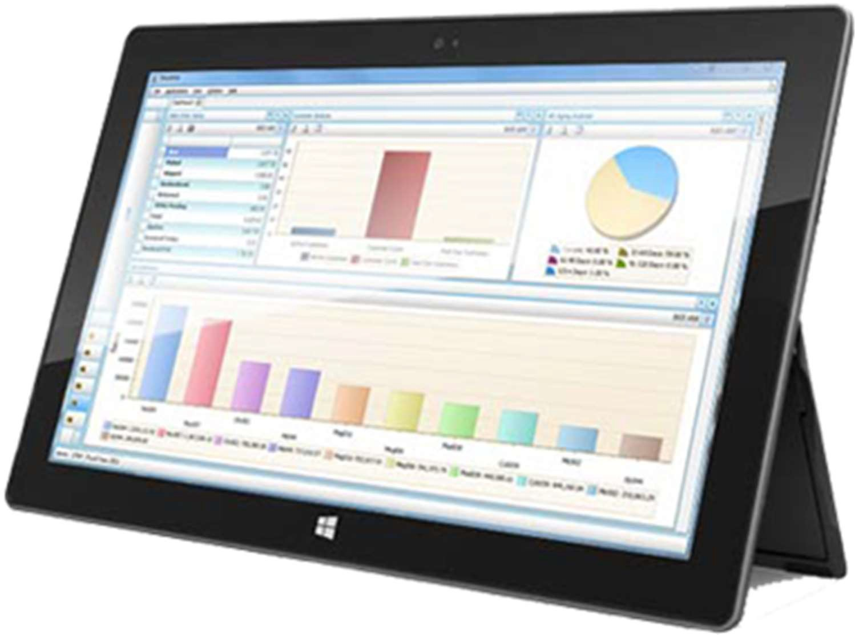

## Product Management Systems

Allows you to manage your all type of inventory in a single application by enabling the In-Stock & Out-Stock functionality including Online Account Management system in built.

27



## Insurance Apps Solutions

Our development team has expertise in Insurance Solutions development & has a great experience on such applications. Our 1st objective is to meet the customer requirement.



Service

Due to unique approach in standardized software development tactics, we are able to provide cost effective and efficient services to our clients and our rates are always comparative to our competitors. Logic Mind Technologies, being a software and web development and solution providing company, we offer variety of custom software development services as per the requirement of client.

LMT Software Solutions Pvt Ltd. - Software Services

* Software Development
* Software Application Development o Customized Software Development o Offshore Software Development
* SOA and SaaS
* Web Application Development
* ASP.NET Web development
* Web Application Maintenance Services
* .Net Technologies like C#, ASP.NET, VB.NET
* Share Point Services/MOSS
* Flex, Silverlight and Ajax
* Website Designing and Graphic Designing
* Application Integration Services
* Web and Graphic Designing
* Mobile Application Development
* Windows Phone Apps Development
* Windows Phone Game Applications

28

### E-governance AP



Logic Mind Technologies has ready to implement solutions for e-Commerce which can be customized and implemented at a short notice. These solutions are developed after conducting detailed System Requirement Study (SRS) of the respective business and have stabilized by the live implementation and are running successfully with state wide implementation.

The marketing department consists of Digital Marketing and Sales departments. The presales department further contains Healthcare, Education, Retail and Networking departments. The digital marketing departments are classified as Public relations, Analyst and Online supermarket for the groceries.

* + ONLINE SUPERMARKET FOR THE GROCERIES: ANDHRAFRESH.COM

ANDHRAFRESH.COM is an Indian online grocery provider listing over 2000+products from more than 500 brands. It was started in Anathapur and subsequently expanded its operations to Kurnool, Tirupati and expanding further in Bangalore, Chennai, Hyderabad, Mysore, Pune.

ANDHRAFRESH.COM product categories include Fresh Fruits and Vegetables, Grocery and Staples, Bread, Dairy, Eggs, Beverages, Branded foods, Household Items, Personal Care, Health care, Meat, Home & Kitchen Products, Electronics & Appliances, Cosmetics, imported products and gourmet products. Many more categories are going to be expanded.

Andhrafresh.com also provides all fresh beverages, foods and home appliances The below showed snapshot of andrafresh.com

29



Fig 2.3 snapshot of andrafresh.com

* + KEY ALLIANCES/PARTENERSHIPS:



Fig 2.4 Alliances with Andrafresh.com symbol

Today a client shop on the web at stands via telephone and cells quickly, its big challenge in coordinating to the online stores, to give best shopping is very big challenge.

30

Logic mind technology uses advance tools to connect people to fulfill their requirements, areas of specialty of logic mind technology are.



* + Responding to customer requirements.
  + Cooperating with customers.
  + Giving presentation to the customers.
  + Business development support.
  + Supporting for market.

### Operation of the company

“To enable its customers to achieve total e-commerce through innovative solutions using the cutting edge technologies and to provide world class IT and ITES services at an affordable costs to the customers with fast turnaround time and to continually improve the service delivery at the client service centers managed by us.”

Over the next few years our goal is to harness our talents and skills by permeating our company further with process-centered management. In this way, once a customer's project enters our quality oriented process, it will exit as a quality product.

We will also strive to add to our knowledge and enhance our skills by creating a learning environment that includes providing internal technology seminars, attending conferences and seminars, building a knowledge library and encouraging learning in every way. Our in-house Intranet portal makes sure that knowledge is shared within the organization.

With our beliefs, the future can only look promising as we continue to build our team with the best Indian talent and mould them into our quality-oriented culture. We will find our niche in a competitive world by excelling at what we do, following our guiding principles and most importantly, listening to the needs of our customers, to complete within deadline period is also our mission.

31

More information about the company



## Milestones

Logic Mind Technologies is a global enterprise solutions provider committed to designing and delivering solutions that enable international companies to thrive in today's complex business environment.

Logic Mind Technologies Pvt Ltd is one of India most well-known and well-trusted solution provider. Today Logic Mind Technologies stands as a source of reliable and innovative products that enhance the quality of customer’s professional and personal lives. With the active participation of its multi- disciplinary Assignment Execution Team, Logic Mind Technologies has emerged as a leader in the ITES in India and has established itself in the field of software development, data processing, data conversion, digital printing, Digitization, System integration, smart card personalization, IT facility management and other IT enabled services. Logic Mind Technologies LLP, incorporated in 2011, is a professionally managed, rapidly growing, multifaceted Information technology company. The company is actively involved in developing automation and e-Governance solutions for Transport, Social Security, Citizen Identity, Education, Public Distribution System, Retail Management and a host of other application areas.

Historical milestones and a variety of achievements characterize our company’s journey: from a merchant’s company selling one product to the state player we are today. Throughout the journey, we have seen many first-time product launches, a steady flow of innovations, continuous expansions through growth and acquisitions. During this time, hundreds of employees have contributed to our success, which is marked by numerous awards and excellent third-party rankings.

Logic Mind Technologies has successfully completed many e-governance projects for the various departments of Govt of AP and has won accolades for its superior service delivery, timely execution of projects and the quality of the deliverables. LMT is being trusted by many clients who are looking for reliable and quality services for their business. LMT is currently operating and managing in Bangalore and giving services to e-commerce business services.

32

## Financial status



Since its inceptions and with initial small steps, Logic Mind Technologies is now progressing by leaps and bounds. It has grown from a small venture to a medium scale enterprise with a strong 80+ workforce, our rate of more than 100%. The company is executing some of the prestigious projects and has earned a very respectable name in the Indian IT and e-commerce industry.

Financial statement often referred to as a Statement of Profit and Loss, or P&L, this financial report shows the revenues and expense generated and incurred by a company over a specified period of time. It shows the net gain or loss from the company's equity position during the stated accounting period. The financials include Income Statements, Balance Sheets, Statements of Cash Flow and Financial Ratios both on a quarterly and an annual basis is 3 crore.

## Technical Activities

“Technical activities” means the doing of any work by the industry itself or the use or installation of any materials, parts or equipment which is subject to regulation by the city under one or more of the technical codes.

Technical skills are the expertise or the technical competency that a professional has in his area of work. To acquire the technical skills the professional needs to have a thorough knowledge about the domain of working. Also, about the advance tools used to implement the solutions designed to solve the problem. Some of the examples for technical skills used in IT industry include: design, development, testing, problem analysis etc.

Technical Activities goal is to promote a profitable and sustainable business activity that meets the customer’s needs, to increase the company's market share, to gain the competitive edge, to increase the company's role in relations to social responsibility and to provide excellent customer service.

## Different Phases of Compilation

### There are 5 phases for compiling a program

Phase 1: Edit

We create the program on editor, after that it stored in the disk with the name's ending .java

33



Phase 2: Compile javac (java compiler)

Compiler translates from high-level language program to byte codes and stores it in disk with the ending name .class.

Phase 3: Load

Class loader compile read and put those byte codes from disk to Primary Memory.

Phase 4: Verify

Verify byte codes to confirm that all byte codes are valid and do not risk for the Java's security restrictions.

Phase 5: Execute

Java Virtual Machine (JVM) read and translates those byte codes to language that computer can understand (Machine Language). Then execute the program, store it values in primary memory.

Compiling and Running Java Program: It's Two Step Process

Develop Java Program

Compile Java Program from Command Prompt Run Java Program from Command Prompt Loading of Classes and Interfaces

Linking of Classes and Interfaces Run Java Program - Initialization

Run Java Program - Invoking Class. main JVM, JRE and JDK

## Modern tool usage

The software team at Logic Mind Technologies has extensively worked on various flavours of Unix and Windows based environment. Few of the Unix operating systems, which have been used by the organisation, are Sun Solaris, Tru64 UNIX & Linux. The team at LMT has developed large scale and complex applications on Oracle, SQL Server and DB2. There is also substantial working expertise on MySql and MSAccess.

34

The web server experience extends to the following:



* + Apache on Unix and NT Servers
  + IIS on NT Platforms
  + J2EE Compliant web servers (JSP version 1.10 & Java Servlet version 2.2)
  + Netscape Server
  + Oracle Web Server

Operating Systems : OS/400, UNIX, Windows 8, Windows 3.11/8.1/10 Database Environment : DB2, Oracle, SQL Server, MS Access, MySQL, CICS Languages : NS2, Java, EJB, XML, RMI, WAP, C/C++, CL/400, RPG

Web Enabled Systems : MS-IIS, Visual Interdev, Websphere, Weblogic

Front End Tools : Visual Basic, Visual C++, Power Builder, VisualAge,

Jbuilder, Developer 2000 Web Designing Tool : FrontPage 2000, Flash Data and Object Modelling : Rational Rose

Our Team members have extensive knowledge in Oracle Products ranging from Oracle 7.3 to 10i, Developer 6i, Oracle 10iAS and other oracle products.

## Successful Build

For successful building of any project we need the following:

1. Business requirements
2. Smart Planning
3. Open Communication hub
4. Calculate Risk Management
5. Strong Project Solutions
6. Proper design development
7. Strong implementation
8. Efficient testing
9. Successful delivery
10. Support maintenance

35

### TASKS PERFORMED



* 1. Overview

Spatial information network is an important part of the integrated space-terrestrial information network, its bearer services are becoming increasingly complex, and real- time requirements are also rising. Due to the structural vulnerability of the spatial information network and the dynamics of the network, this poses a serious challenge to how to ensure reliable and stable data transmission

Software defined network(SDN) is used to design the spatial information network architecture. Software Defined Network (SDN) is a logical centralized network model, which is characterized by data plane and control plane separation, with a logical centralized control plane, and through a unified and opened south interface to achieve the control of the network. It also supports dynamic and flexible management, and becomes the ideal model to achieve high bandwidth and dynamic network. SDN separates control of network devices and is managed by a centralized controller without relying on underlying network devices (routers, switches, firewalls), and shielding the differences of underlying network devices.

36



### Scope and Objective of the Project

Operating and maintaining a computer network is an arduous task. To express the required high-level network policies, network operators need to conjure each individual network device separately from a heterogeneous collection of switches, routers, middle boxes, etc. using vendor specie and low-level commands. In addition to conjuration complexity, networks are dynamic, and operators have little or no mechanisms to automatically respond to network events. It is therefore decal to enforce the required policies in such a continually changing environment.

* 1. EXISTING WORK

No proper cluster framing mechanism with proper energies allocation. Cluster head mechanism with shortest path finding is not there. Making the cluster head as edge node is applicable

Shortest path with respect to aggregated energies threshold is rare.

* 1. Problem Statement

Traditional networks have “natural protections” against common threats and vulnerabilities that SDNs in principle do not.

* + - Closed (proprietary) nature of network devices.
    - Heterogeneity of software.
    - Decentralized nature of the control plane

### Objective

* + - Operating and maintaining a computer network is an arduous task. To express the required high-level network policies, network operators need to conjure each individual network device separately from a heterogeneous collection of switches, routers, middle boxes, etc. using vendor specie and low-level commands.
    - In addition to conjuration complexity, networks are dynamic, and operators have little or no mechanisms to automatically respond to network events. It is therefore decal to enforce the required policies in such a continually changing environment.

37



### Keywords

Security, Dependability, SDN, Reliability, Threat Vectors, Controllers

### Methodology

* + - In this section we present the general design of the secure and dependable SDN control platform we propose. In the remainder of this section we briey introduce and discuss the several mechanisms which we consider using to address the threat vectors identied in SDNs.
    - Diversity. Another relevant technique to improve the robustness of secure and dependable systems is diversity. Replication with diverse controllers is a good starting case.
    - The basic principle behind this mechanism is to avoid common-mode faults (e.g., software bugs or vulnerabilities).For example, it is known that o-the-shelf operating systems, from deferent families, have few intersecting vulnerabilities, which means that OS diversity constrains the overall eject of attacks on common vulnerabilities.

### Security & Dependability

* + - Replication
    - Diversity
    - Self-healing mechanisms
    - Dynamic device association
    - Trust between controllers and devices 20 Security & Dependability
    - Trust between applications and controller software
    - Security domains
    - Secure components
    - Fast and reliable software update and patching y & Dependability
    - If a switch is associated with a single controller, its control plane does not tolerate faults. Once the controller fails, the control operation of the switch fails and the switch will need to associate with another controller.
    - For this reason, a switch should be able to dynamically associate with several controllers in a secure way (e.g., by using threshold cryptography to detect malicious controllers and authentication, which would hinder man-in-the-middle attacks, for instance).

38

* + - A switch associated with deferent controllers would be able to automatically tolerate faults (crash or Byzantine, depending on the conjuration). Other advantages include increasing control



* + - To the best of our knowledge, none of the SDN controllers proposed thus far address security and dependability beyond using simple authenticated communication channels and control data replication among controller instances. For example, no mechanisms are used to assure trusted switch controller association (to avoid malicious devices in the network) or to detect, correct or mask faults of system components.
    - Moreover, no techniques are used to assure data integrity and congeniality in or between controllers. In a security and dependability perspective, one of the key ingredients to guarantee a highly robust system is fault and intrusion tolerance.
    - The two main fault models are crash and Byzantine (a.k.a., arbitrary faults). Crash fault tolerant services support only benign failures such as a crashed process, operating system or machine, being a narrow subset of the arbitrary model. Byzantine fault tolerant (BFT) systems are capable of tolerating any abnormal behaviour,i.e., intentional or non-intentional faults, while the service keeps its correct operation. Faults (e.g., bugs, miscongurations, attacks) and errors can be masked automatically as they happen, by using state machine replication
    - Furthermore, in order to ensure the perpetual and unattended operation of the system, errors can be removed with self healing techniques, so that there is never an excessive number of compromised devices. Both automatic recovery and perpetual and unattended operation seem to be relevant objectives in the context of SDNs.The literature on Byzantine fault tolerance is broad, ranging from large-scale systems to resource cient solutions. Nevertheless, BFT alone is not enough to guarantee a highly available dependable system, needing self healing mechanisms as a complement. Techniques such as proactive-reactive recovery, for example, can be used to assure the system livens.
    - These techniques rely on the idea of rejuvenating compromised components (be it by accidental or malicious faults). Intrusion-tolerant architectures are a step in the direction of this automatic security paradigm. Intrusion-tolerant systems remain working correctly and are capable of assuring properties such as integrity, congeniality and availability, despite the presence of faulty or compromised components due to successful attacks.
    - A secure and dependable control plane helps improve the overall network resilience, which is journal goal. A resilient system is one that self-adapts to the dynamics of environment conditions, e.g., one that performs self-healing in the presence of persistent threats and where protection parameters, such as number of replicas, length of keys, etc., can automatically increase in case of a severe attack.

39

### 5.0 PROPOSED SYSTEM



Cluster framing with dynamic range of energy allocation with proper central repository control. Shortest path is two way, one is to make source- cluster head (edge) -cluster head(edge other side cluster)-destination. Edge nodes are always cluster heads. Based on the threshold , shortest path should be made according to the aggregated threshold . So the node which satisfies this will only come into shortest path.

* 1. WHAT IS SDN

Software-defined networking (SDN) is an architecture that aims to make networks agile and flexible. The goal of SDN is to improve network control by enabling enterprises and service providers to respond quickly to changing business requirements. In a software-defined network, a network engineer or administrator can shape traffic from a centralized control console without having to touch individual switches in the network. The centralized sdn controllers directs the switches to deliver network services wherever they're needed, regardless of the specific connections between a server and devices. This process is a move away from traditional network architecture, in which individual network devices make traffic decisions based on their configured routing tables.

* 1. SDN architecture

A typical representation of SDN architecture comprises three layers: the application layer, the control layer and the infrastructure layer.

The control layer represents the centralized SDN controller software that acts as the brain of the software-defined network. This controller resides on a server and manages policies and the flow of traffic throughout the network.

40

### The infrastructure layer is made up of the physical switches in the network.

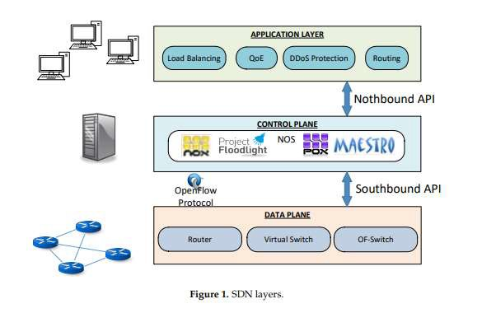

Fig 6.1 SDN Layers

### The application layer, not surprisingly, contains the typical network applications or functions organizations use, which can include intrusion detection systems, load balancing or firewalls. Where a traditional network would use a specialized appliance, such as a firewall or load balancer, a software-defined network replaces the appliance with an application that uses the controller to manage data plane behaviour.

41

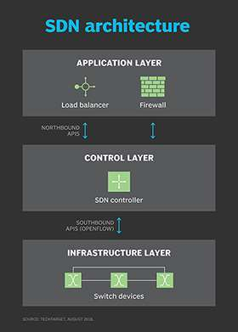

### Fig 6.1 SDN Architecture

SDN architecture separates the network into three distinguishable layers, connected through northbound and southbound APIs.

These three layers communicate using respective northbound and southbound application programming interfaces (APIs). For example, applications talk to the controller through its northbound interface, while the controller and switches communicate using southbound interfaces, such as OpenFlow -- although other protocols exist. There is currently no formal standard for the controller's northbound API to match OpenFlow as a general southbound interface. It is likely the OpenDaylight controller's northbound API may emerge as a de facto standard over time, given its broad vendor support.

42

### How SDN works



SDN encompasses several types of technologies, including functional separation, network virtualization and automation through programmability. Originally, SDN technology focused solely on separation of the network control plane from the data plane. While the control plane makes decisions about how packets should flow through the network, the data plane actually moves packets from place to place.

In a classic SDN scenario, a packet arrives at a network switch, and rules built into the switch's proprietary firmware tell the switch where to forward the packet. These packet-handling rules are sent to the switch from the centralized controller.

The switch -- also known as a data plane device -- queries the controller for guidance as needed, and it provides the controller with information about traffic it handles. The switch sends every packet going to the same destination along the same path and treats all the packets the exact same way.

Software-defined networking uses an operation mode that is sometimes

called adaptive or dynamic, in which a switch issues a route request to a controller for a packet that does not have a specific route. This process is separate from adaptive routing, which issues route requests through routers and algorithms based on the network topology, not through a controller.

The virtualization aspect of SDN comes into play through a virtual overlay, which is a logically separate network on top of the physical network. Users can implement end- to-end overlays to abstract the underlying network and segment network traffic. This microsegmentation is especially useful for service providers and operators with

multi-tenantcloud environments and cloud services, as they can provision a separate

virtual network with specific policies for each tenant.

43

### Benefits of SDN



With SDN, an administrator can change any network switch's rules when necessary -- prioritizing, deprioritizing or even blocking specific types of packets with a granular level of control and security. This is especially helpful in a cloudcomputing multi- tenant architecture, because it enables the administrator to manage traffic loads in a flexible and more efficient manner. Essentially, this enables the administrator to use less expensive commodity switches and have more control over network traffic flow than ever before.

Other benefits of SDN are network management and end-to-end visibility. A network administrator need only deal with one centralized controller to distribute policies to the connected switches, instead of configuring multiple individual devices. This capability is also a security advantage because the controller can monitor traffic and deploy security policies. If the controller deems traffic suspicious, for example, it can reroute or drop the packets.

SDN also virtualizes hardware and services that were previously carried out by dedicated hardware, resulting in the touted benefits of a reduced hardware footprint and lower operational costs.

Additionally, software-defined networking contributed to the emergence of software- defined wide area network (SD-WAN) technology. SD-WAN employs the virtual overlay aspect of SDN technology, abstracting an organization's connectivity links throughout its WAN and creating a virtual network that can use whichever connection the controller deems fit to send traffic.

44

### Challenges with SDN



Security is both a benefit and a concern with SDN technology. The centralized SDN controller presents a single point of failure and, if targeted by an attacker, can prove detrimental to the network.

Ironically, another challenge with SDN is there's really no established definition

of software-defined networking in the networking industry. Different vendors offer various approaches to SDN, ranging from hardware-centric models and virtualization platforms to hyper-converged networking designs and controllerless methods.

Some networking initiatives are often mistaken for SDN, including white box networking, network disaggregation, network automation and programmable networking. While SDN can benefit and work with these technologies and processes, it remains a separate technology.

SDN technology emerged with a lot of hype around 2011, when it was introduced alongside the OpenFlow protocol. Since then, adoption has been relatively slow, especially among enterprises that have smaller networks and fewer resources. Also, many enterprises cite the cost of SDN deployment to be a deterring factor.

Main adopters of SDN include service providers, network operators, telecoms and carriers, along with large companies, like Facebook and Google, all of which have the resources to tackle and contribute to an emerging technology.

45

### SDN Tool Images

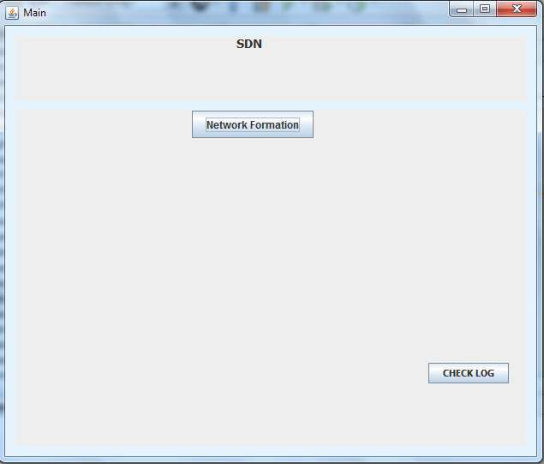

46

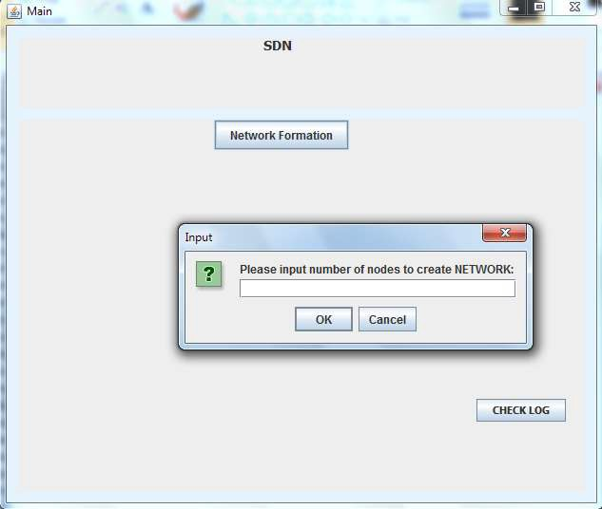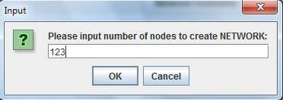

47

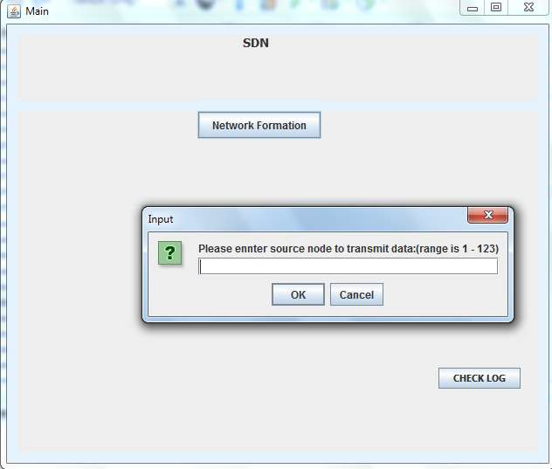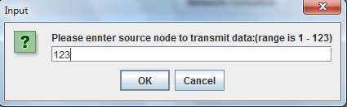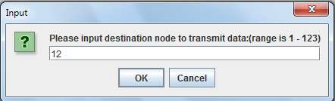

48

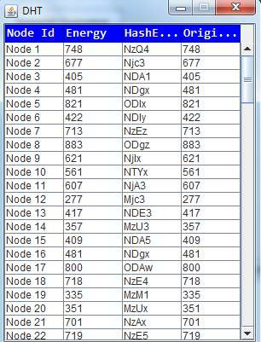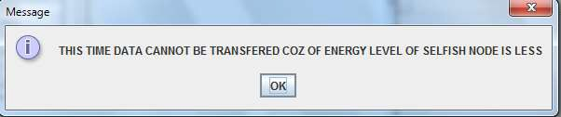

49

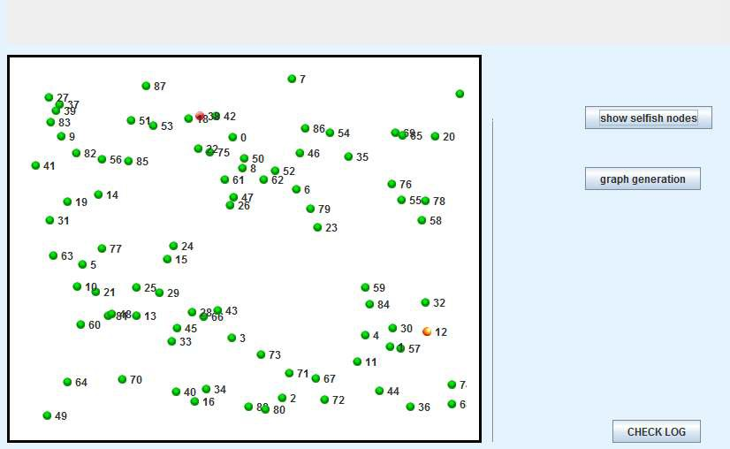

50

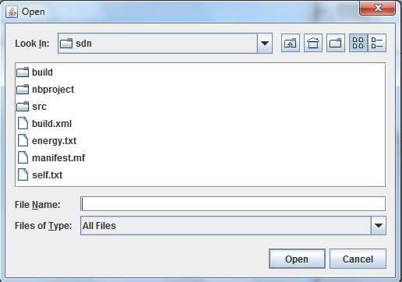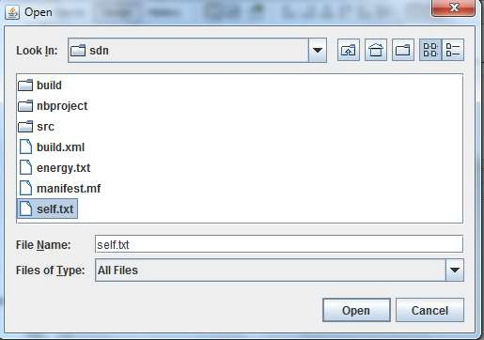

### Fig 6.5 SDN Tools

51

### WIRELESS SENSOR NETWORK



Wireless sensor network (WSN) refers to a group of spatially dispersed and dedicated sensors for monitoring and recording the physical conditions of the environment and organizing the collected data at a central location

The WSN is built of "nodes" – from a few to several hundreds or even thousands, where each node is connected to one (or sometimes several) sensors. The topology of the WSNs can vary from a simple star network to an advanced multi-hop wireless mess network.

The propagation technique between the hops of the network can be routing

* 1. Block Diagram

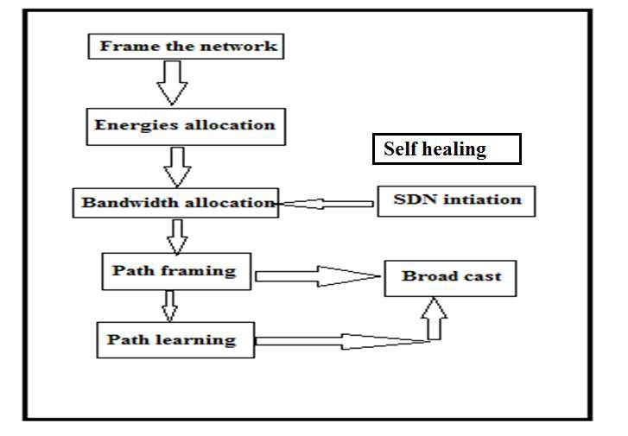

Fig 7.1 Wireless sensor Block diagram

52

### 8.0 ROTA ALGORITHM



This is a set of identical binary to strings(text) encoded models that indicates binary data with ASCII text format by converting/translating to RADIX-64 notations

The ASCII characters utilized for Rota are the numbers 0-9, the letter sets 26 lowercase and 26 capitalized characters in addition to two additional characters "+" and '/'.

The initial step is to take the three bytes (24bit) of parallel information and split it into four quantities of six bits. Since the ASCII standard characterizes the utilization of seven bits, Rota just uses 6 bits (comparing to 2^6 = 64 characters) to guarantee the encoded information is printable and none of the uncommon characters accessible in ASCII are utilized.

At the point when the quantity of bytes to encode is not distinct by 3 (that is, if there are just a single or two bytes of contribution for the last 24-bit square), then the accompanying activity is performed: Add additional bytes with esteem zero so there are three bytes, and play out the change to Rota.

On the off chance that there was just a single huge information byte, just the initial

two Rota digits are picked (12 bits), and if there were two critical info bytes, the initial three Rota digits are picked (18 bits). "=" characters may be added to make the last piece contain four Rota characters.

53

### 9.0 APPLICATION OF SDN



1. Security Services. The modern virtualization ecosystem supports specific virtual services running within the network layer. This means incorporating functions like NFV into SDN platforms. This type of network security creates a truly proactive environment capable of reducing risk and responding to incidents much more quickly. When a breach occurs, every second is critical in stopping the attack. Also important is the capability to identify the attack and ensure that other network components are safe. As the network layer becomes even more critical -- and as the modern organization becomes even more digitized – we’ll see more attacks and more sophisticated advanced persistent threats. By integrating powerful security services into the SDN layer, you help create a more proactive environment that’s capable of responding to change.
2. Network Intelligence and Monitoring. Modern SDN technologies are helping abstract one of the most critical layers within the data center: the network. Network architectures are much more complex and have to handle more data than ever before. This means knowing what’s flowing through your environment is critical. Do you have latency issues on a port? What if you’re running a heterogeneous network

architecture? Or, are you heavily virtualized and are passing a lot of traffic through the network layer? All of these challenges are alleviated when you have a solid network intelligence and monitoring layer. However, you gain true insight and benefit by integrating these technologies into your SDN architecture. Traffic flow, port configurations, hypervisor integration, alerting, and even optimization can be integrated into network intelligence and monitoring technologies. Most of all, these types of agile systems will further help you monitor network traffic between your data center and your cloud ecosystem.

1. Compliance and Regulation-Bound Applications. Major cloud vendors are now offering the capability to store and work with compliance-bound workloads. Now,

54

### organizations have the option of extending architectures which were originally very limited because of regulations into distributed environments and the cloud. But how do you segment the traffic? How do you ensure that compliance and regulation workloads are persistently secured and monitored? This is where SDN can help. Network traffic traveling between switches, network points, and even hypervisors can all be controlled in an SDN architecture. Remember, this layer abstracts virtual functions and hardware controls. This powerful layer can then span various locations, virtualization points, and even cloud locations.



1. High-Performance Applications. We’re seeing a boom in new types of application technologies. Virtualization has allowed the delivery of rich apps like GIS, CAD, engineering, and graphics design software. Traditionally, these workloads needed bare-metal architectures with their own connection. However, with virtualization, applications are streamed and VDI can help create powerful desktop experiences.

However, at the network layer we also see the integration of SDN into application control. Creating powerful QoS policies, securing confidential data, segmenting heavy traffic, and even creating threshold alerts around bottlenecks. All of these functions within SDN help support high-performance, rich applications which are being delivered via virtualization.

1. Distributed Application Control and Cloud Integration. One of the biggest benefits of SDN is its capability to extend across the entire data center. This type of agility integrates distributed locations, cloud, and the entire organization. SDN allows for critical network traffic to pass between various locations, regardless of the type of underlying network architecture. By abstracting critical network controls you allow for easier movement of data between data center and cloud locations. Because SDN is a form of network virtualization, you can use powerful APIs to not only integrate with a cloud provider; you can control specific network services as well. This allows you to granularly manage your workloads while keeping your business agile.

55

### PROJECT OUTCOMES



* + - SDNs bring a very fascinating dilemma
    - an extremely promising evolution of networking architectures versus a dangerous increase in the threat surface.

11.0 USE CASE

Multi-tenancy in Cloud Computing Environment In a cloud environment, abstraction of the management layer becomes important to enable more interaction of applications with the networking elements. The virtual network overlay abstracts the underlying physical network, which allows the overlay to move to other physical networks. Virtual Network Overlay stack for Cloud OpenStack OpenStack Plug-in Rest API Virtual Network Switch Hypervisor Tenant 1 Tenant 2 Tenant 3 VXLAN

12.0 CHALLENGE

To support co-existence with existing devices the existing technologies must have additional enhancement. For ex, the existing standard path computation elements in routers are not sufficient, they need to be enhanced. Future Expectation To find a unique SDN approach.

13.0 SOME FREQUENTLY RAISED QUESTIONS

Why is SDN taking so long to adopt?

* Enterprises confused about how SDN will specifically save them on network costs
* No compelling use-cases Is SDN and network virtualization same? • similar goals
* overlapping sets of technologies

56

### 14.0 CONCLUSION



SDN promises to transform today’s static networks into flexible ,scalable, programmable platforms with the intelligence to allocate resources dynamically. With its many advantages and astonishing industry momentum, SDN is on the way to become- the new approach for networking.

SDN can be expanded beyond actual match/action paradigm. For example, it could integrate middleboxes or programmable custom packet processors. This integration could offers new services like on the fly encryption, transcoding, or traffic classification. This require coordination, consensus and vendor support.

In control plane, the composing and coupling of heterogeneous components are still difficult. For example, compose application using Beacon, POX or Floodlight simultaneously.

Finally, remark that SDN is a tool. The research community can use this tool to create new innovative services and applications.

57

### 15.0 REFERENCES



[1] T. Koponen et al.\Onix: a distributed control platform for large-scale production networks".

In: OSDI. 2010.

[2] N. Gude et al. \NOX: towards an operating system for networks". In: Comp. Comm. Rev. (2008). [3] M. Caesar et al.\Design and implementation of a routing control platform". In: NSDI. 2005.

[4] M. Casado et al.\Rethinking Enterprise Network Control". In: IEEE/ACM Trans. on Networking 17.4 (2009).

[5] P. Porras et al. \A security enforcement kernel for OpenFlow networks". In: HotSDN. ACM, 2012. [6]S. Shin et al. \FRESCO: Modular Composable Security Services for Software-Dened Networks". In:

Internet Society NDSS. 2013

[7] N. McKeown et al. \OpenFlow: enabling innovation in campus networks". In: Comput. Commun. Rev. (2008).

[8] S. Sorensen. Security implications of software-dened networks. 2012. [9] S. M. Kerner. Is SDN Secure? 2013.

58